Microsoft Teams is a persistent chat-based collaboration platform complete with document sharing, online meetings, and many more extremely useful features for business communications. Microsoft Teams can be used both online through a browser or as an application on Windows, Mac, iOS or Android. You must log in to Teams using your official UTSA email id. Upon loading Teams on a computer, on the left panel, you will see a list of options available – Activity, Chat, Teams, Assignments, Calendar, Calls, Files, and More.

Use case for Microsoft Teams?
Teams should be used for shared files and folders for departmental and small groups. Each Microsoft team supports up to twenty-five terabytes of storage.

Contents
Chat With Others 2
Create a Team 3
Add Members 6
Manage Permissions 7
Share Files 9
Create File Within Teams 9
Upload Existing File 11
Teams Channel 13
Create a Meeting 16

Chat With Others
- Click the "Chat" button on the left of the application screen.
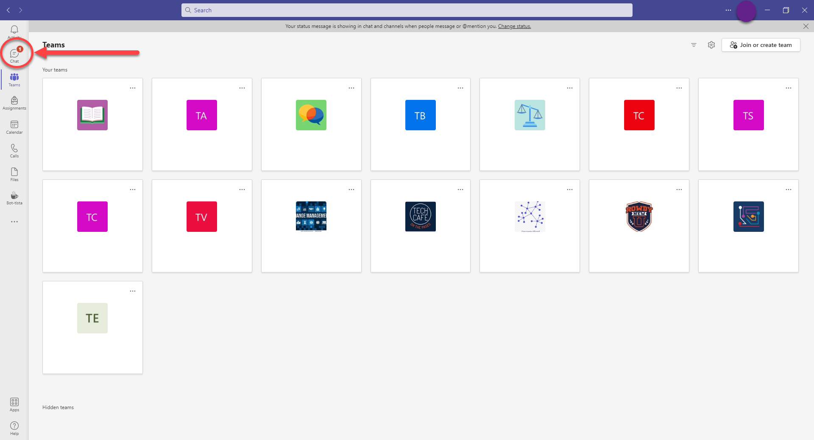
- You can search for someone by using the full name or email address.
- You can send an instant message, give them a call (video or audio only), and share your screen.
  - Instant message.
  - 1) Video or Audio Call. 2) Share Screen

Create a Team
- Open Microsoft Teams.
- Select "Create a team."
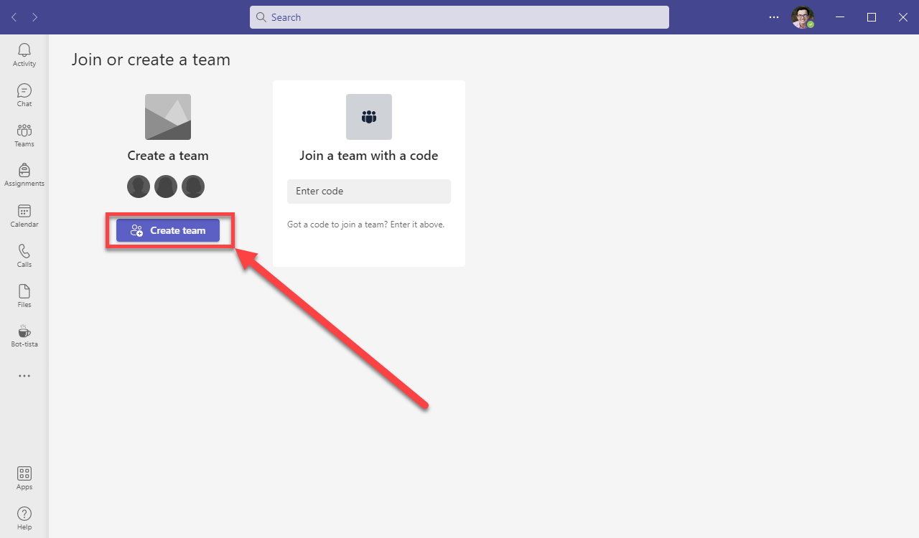

- Select which kind of Team you would like to create.
  - Commonly either "Staff" or "Other."
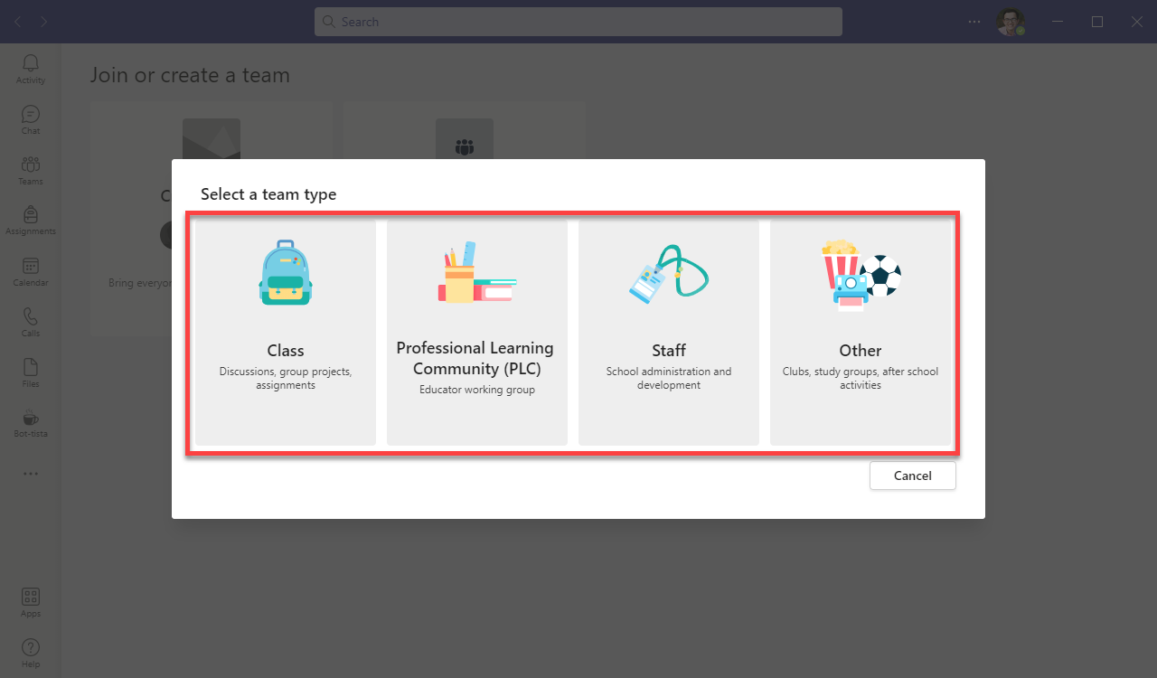

- Enter a name for your Team and select the Privacy options for your Team.
  - The description is optional.
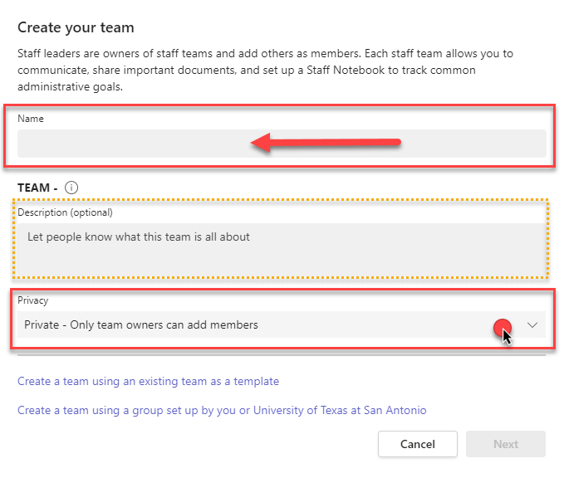

- Next, Add People you would like to add to your "Team."
  - Add members to your Team by typing in their name/email/abc123.
  - If you would like to do this later, you can click skip.
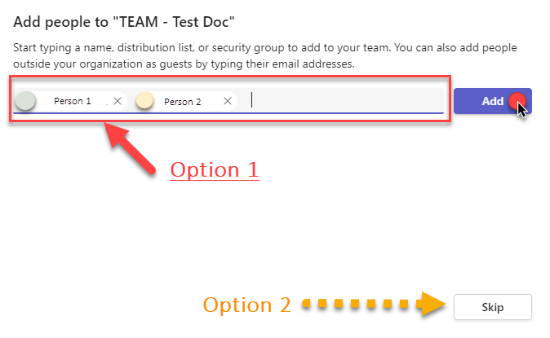

- You will now see your Team on the home screen.
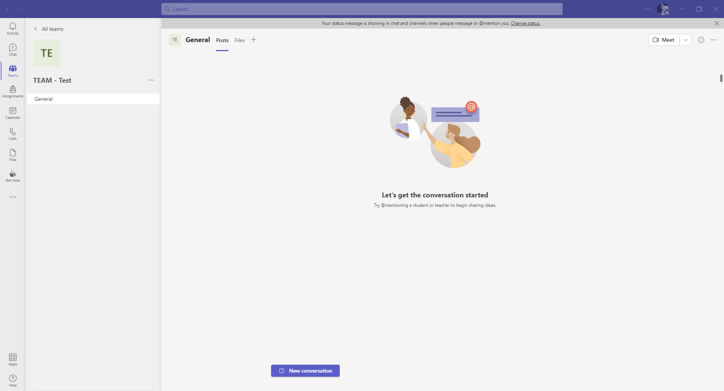

Add Members
- Select the three dots in the top right of your new Team and click "Manage team" or "Add Member."

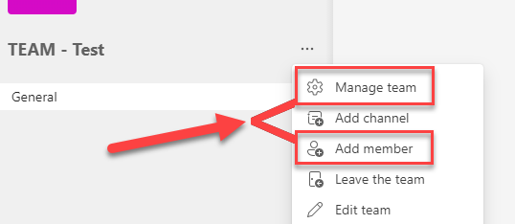

  - If "Add member" is selected:
    - Type the names of the individual and then click "Add."
      - When done, click "Close."
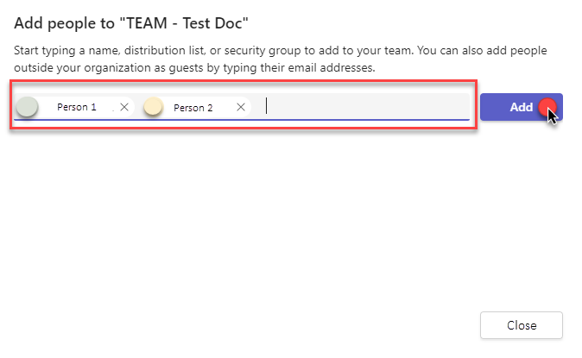

  - If "Manage team" is selected:
    - Under the "Members" tab, you can add more members or change the "Role" of individual members.
      - You can choose between "Member" and "Owner."
        - Depending on the Permission setting will determine the abilities of the two levels.
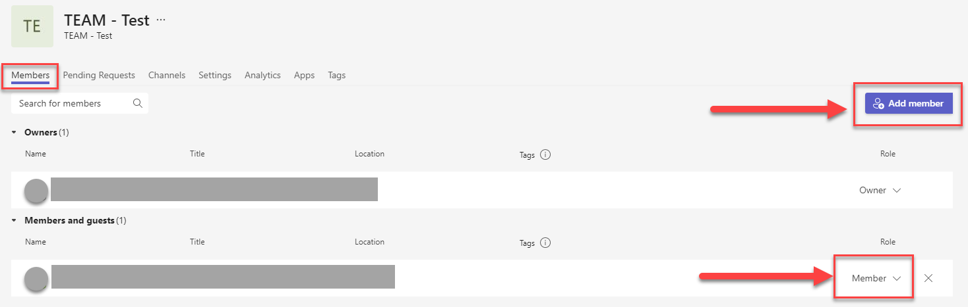

Manage Permissions

- Select the three dots in the top right of your new Team and click "Manage team."

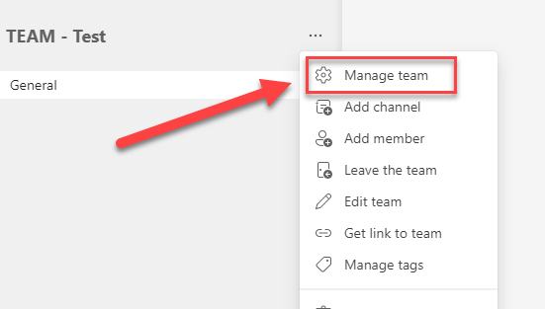

- Under your Team's title and profile picture, select the "Settings" tab.
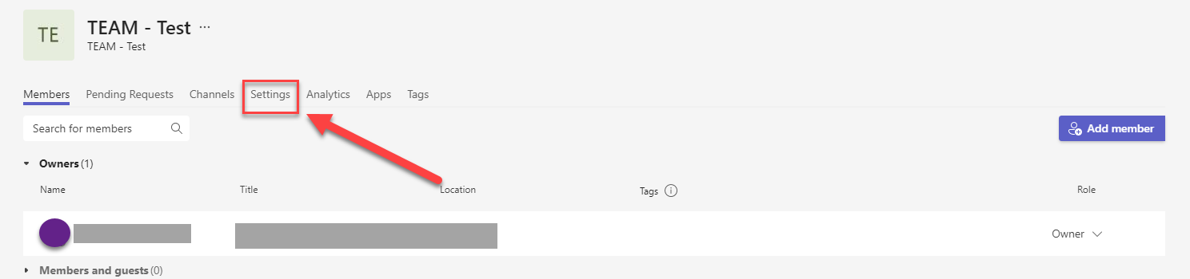

- Click on "Member permissions" to see what you want to allow your members to do.
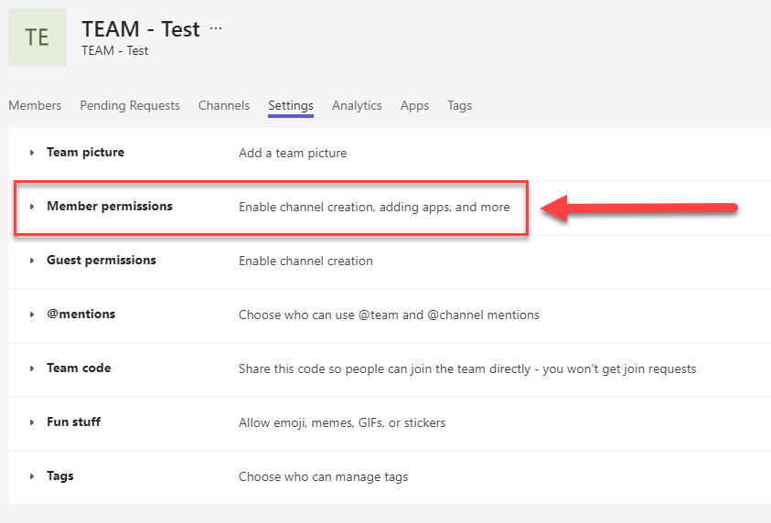

- From here, you can decide what permissions Members will have within the Team.
  - If you want to restrict who can make these types of changes, you can disable all and make select people "Owners" to help manage these changes.
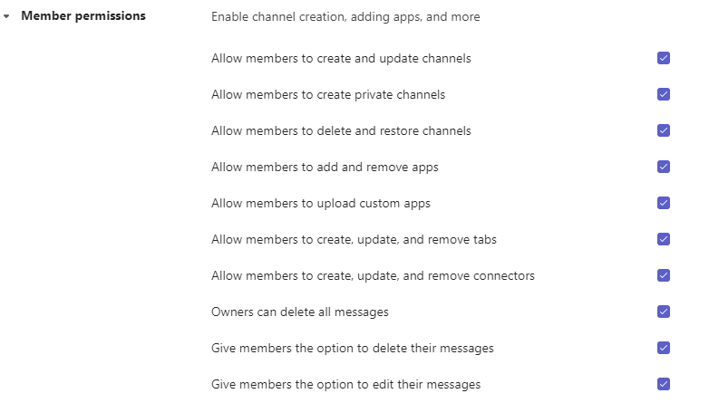

Share Files
There are a couple of ways you can share files within your Team. You can either create the file within the Team or upload an already existing file.

Create File Within Teams
- Go to the "Files" tab within the Team to create a new file.
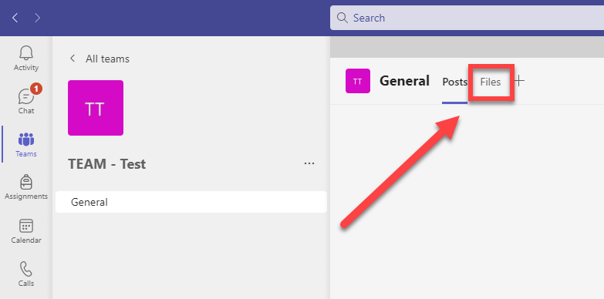
- Click the "New" button and select what file type you want to create.
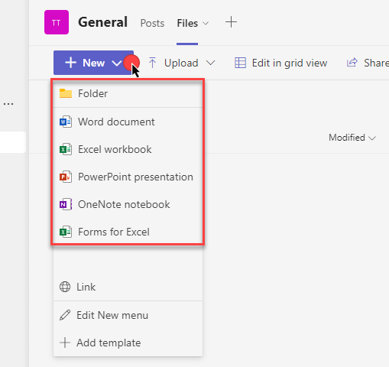
- Enter the desired file name and click "Create."
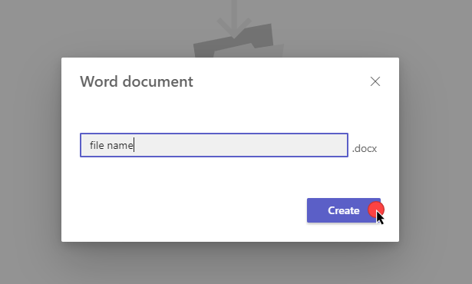
- Your new file will appear.
  - Any changes made will be automatically saved.
  - When you are done, click "Close."
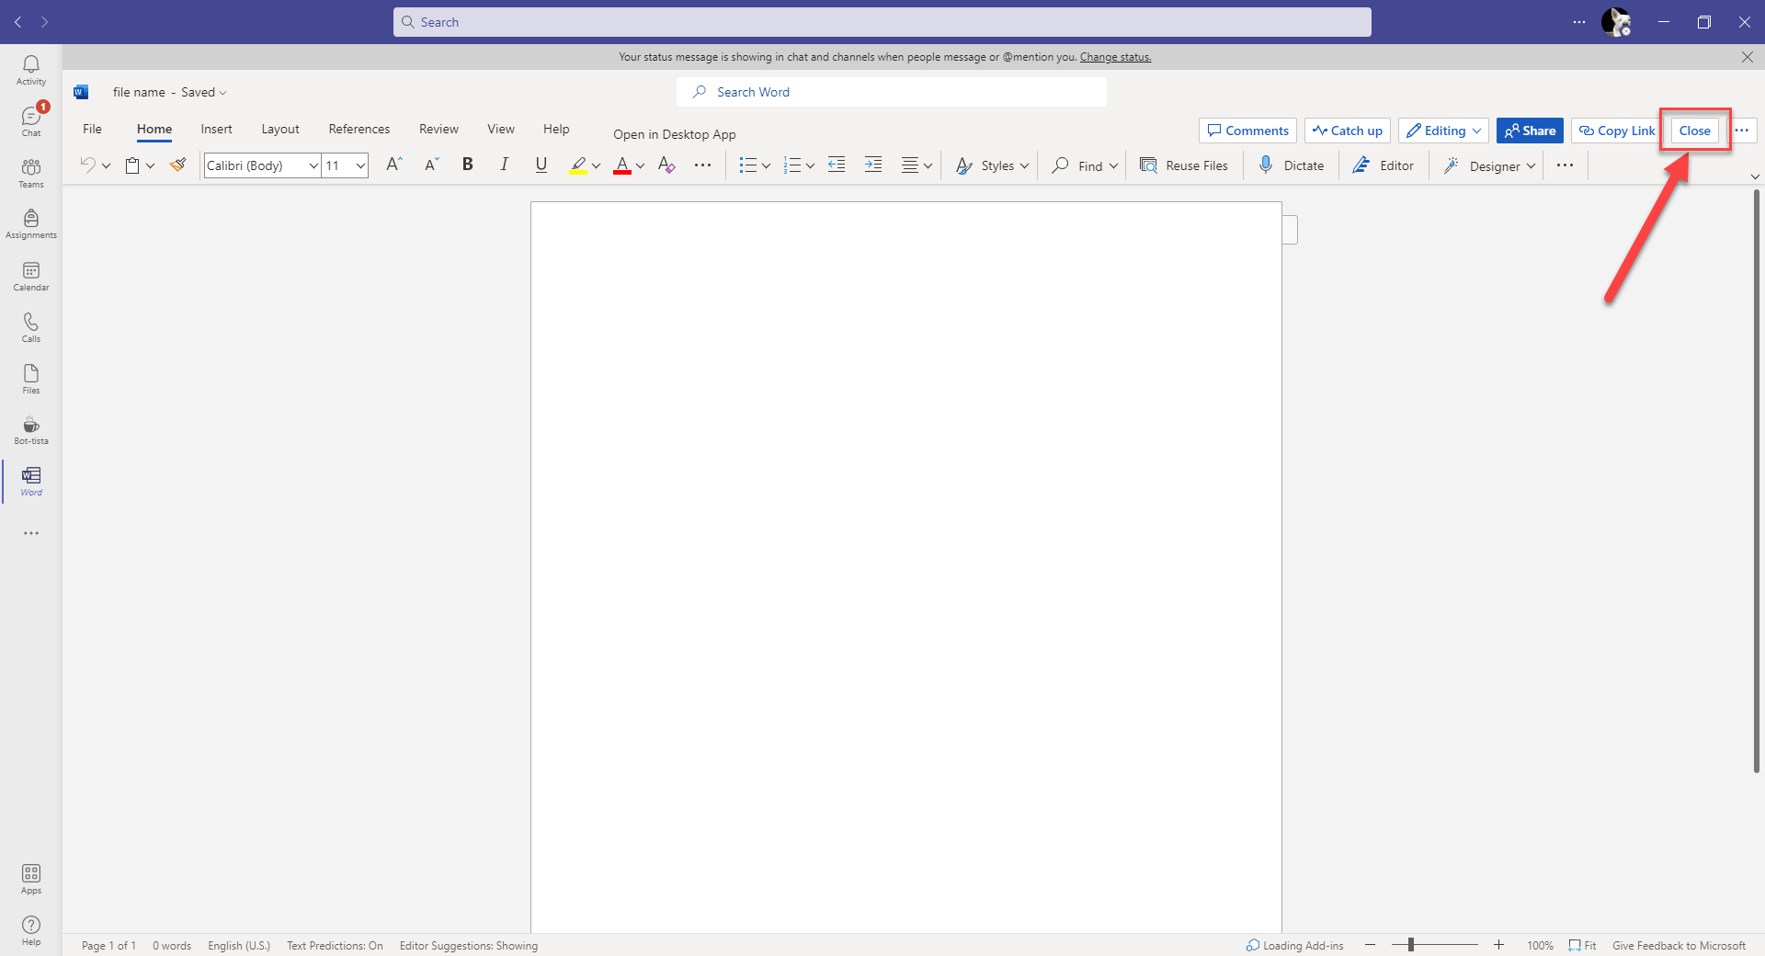
- You can find this file again by going back into your Team and selecting "Files."
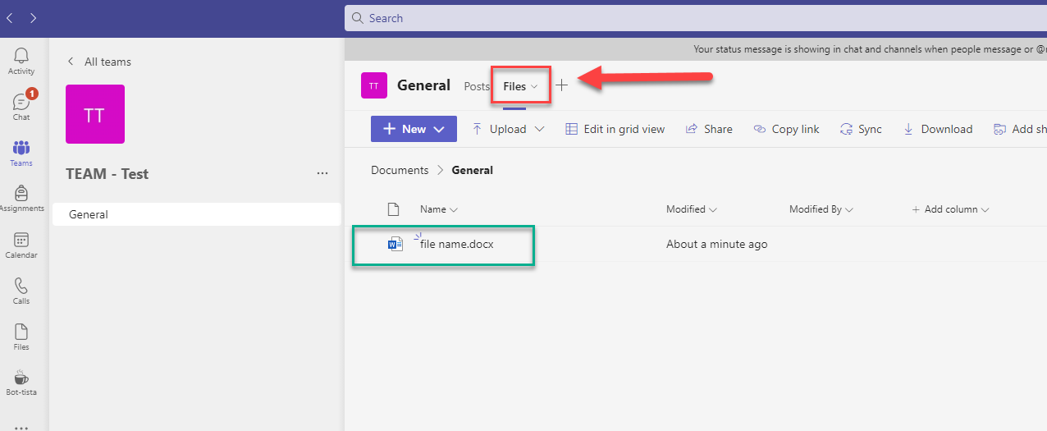

Upload Existing File
- Go to the "Files" tab within the Team.
- Select "Upload" and select the type of item you wish to upload.
  - For this demo, we will upload a file.
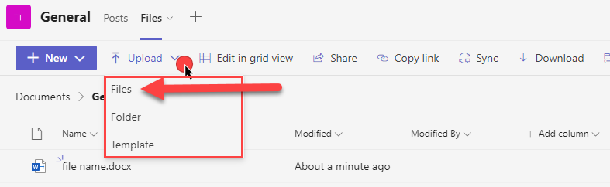
- Locate the file you want to upload, select the file and then click "Open."
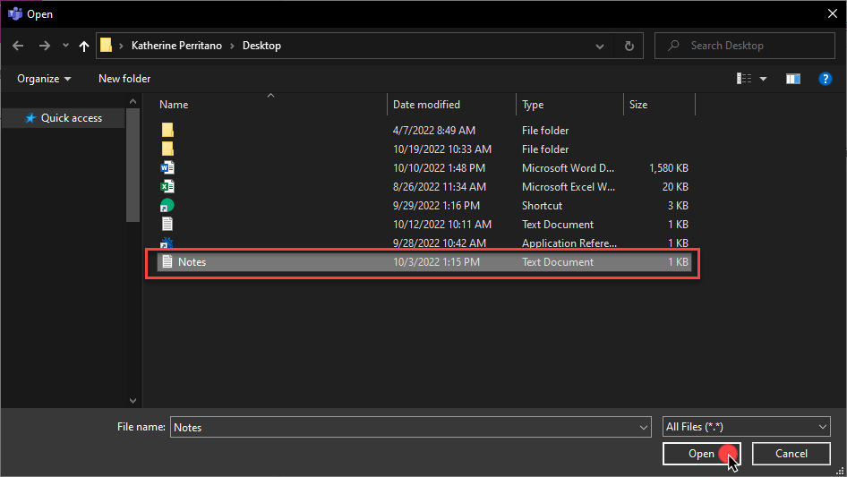
- Your uploaded file will appear under your Team's "Files" tab.
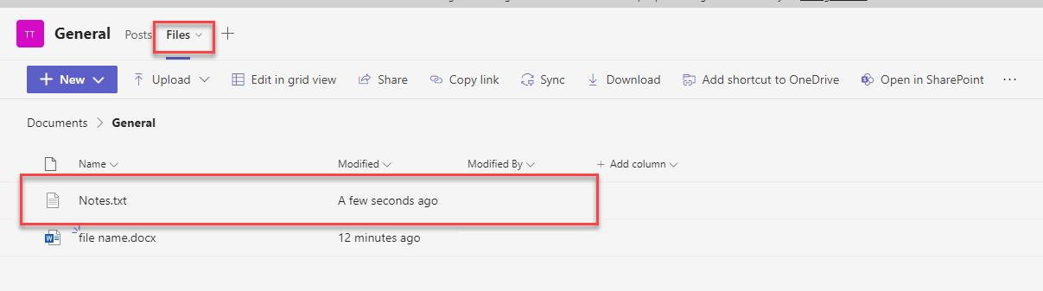
- Anyone with access to the Team will have access to this file.

Teams Channel
Creating channels within a Team can help when it comes to larger Teams. For example, when a department wants to have all faculty and staff within one Team but has a project that only a handful of people need to work on. Within the Team, you can create a channel and restrict access to only the selected people. This helps keep everything in a convenient location but limits access to some materials.
- While in your Team, click the three dots next to your team name and click "Add channel."
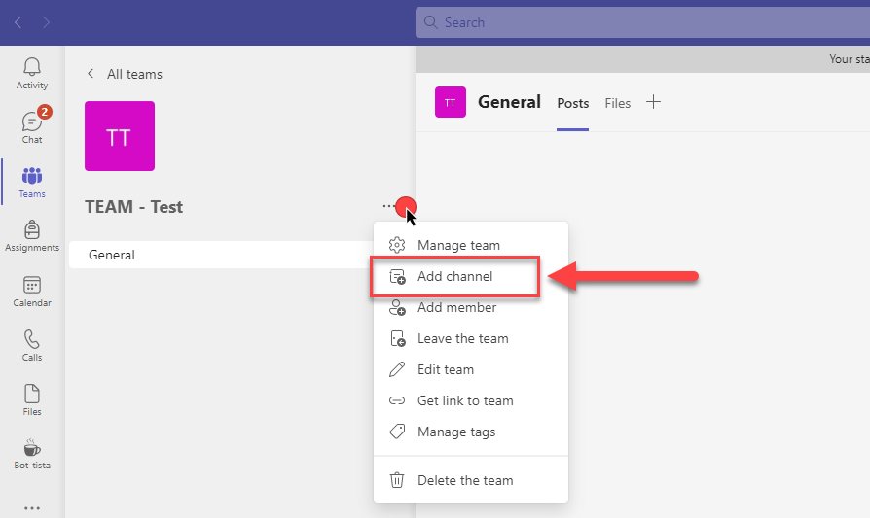
- Next, name your channel and change the "Privacy."
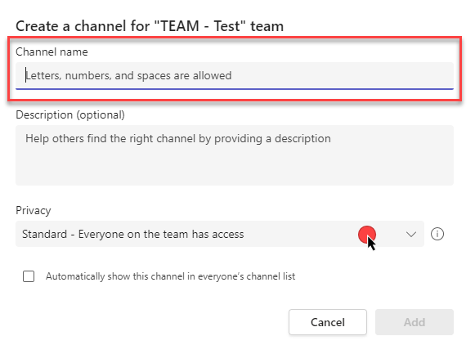
- If you want to restrict access, change the privacy to "Private."
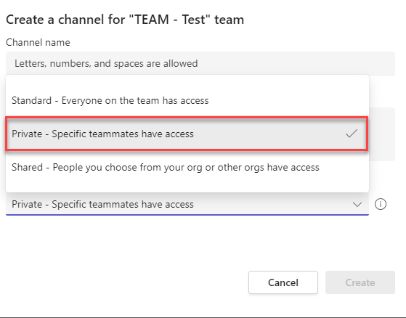
- With your new privacy setting selected, click "Create."
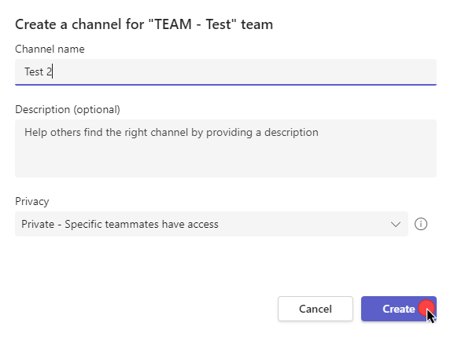
- Add the people you want to have access and click "Add" and then "Close."
- Now your new channel will appear within your Team.
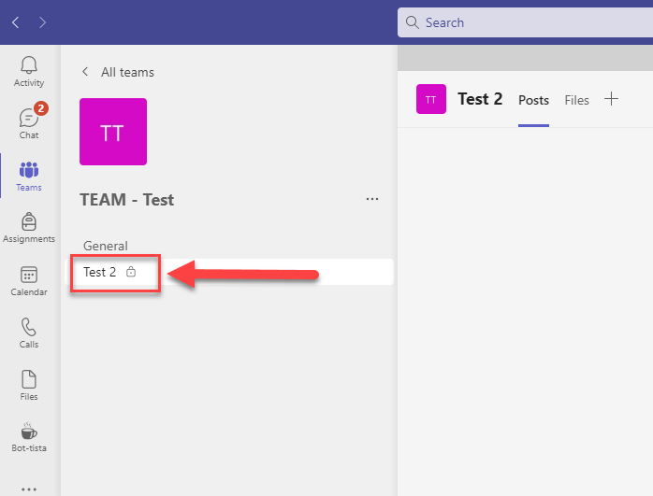

- Now you can use this channel like your main Team.
  - To make any permission changes or add members, you can click the three dots for the channel itself.
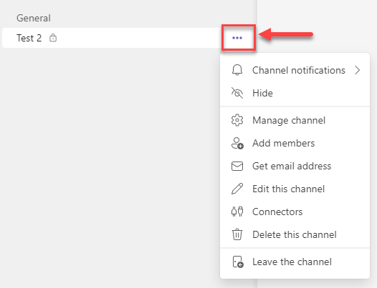

Create a Meeting
- Go to your Calendar
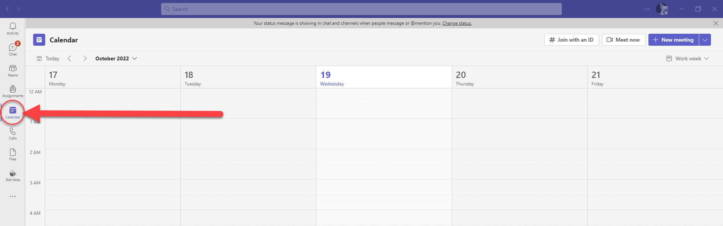
- Click "New meeting."
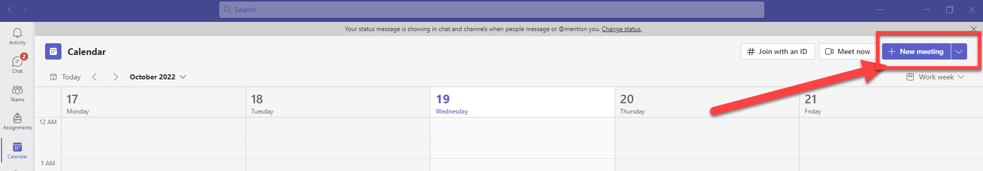
- You can give the meeting a title, add people, select a date and time, choose the duration of the meeting, and any other information. Once done, click "Save."
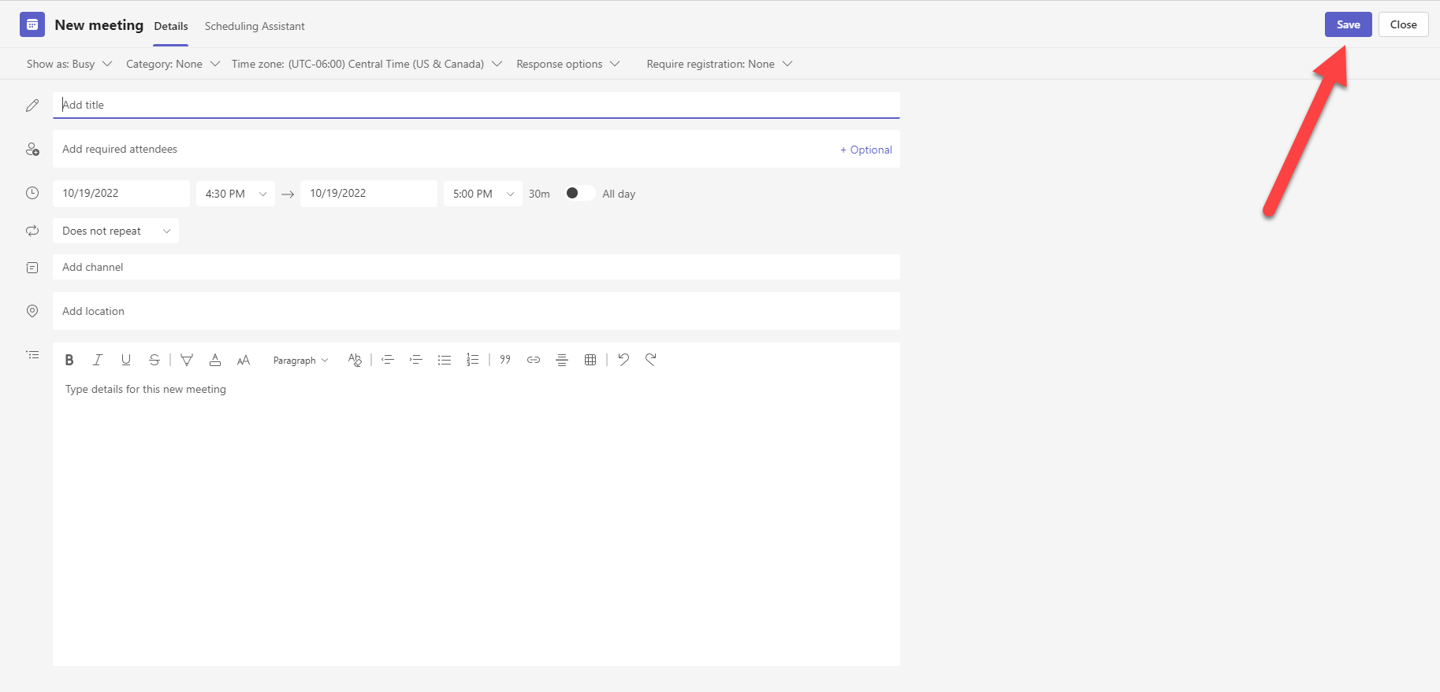

- Now your meeting will appear on your calendar. You can return here to join the meeting as well.
